**If-then Scripts:**

**Check the variable**

#!/bin/bash

count=100

if [ $count -eq 100 ]

then

echo Count is 100

else

echo Count is not 100

fi

create a script file

vi ifvariable.bash

write a script as above

Give permissions to script file

Execute the script file

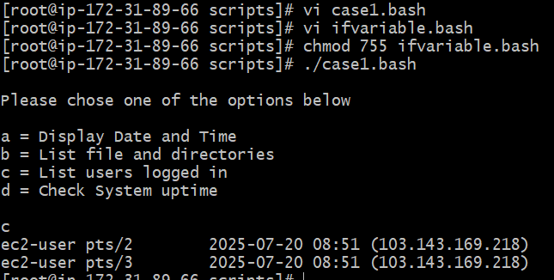

**Check if a file error.txt exist**

#!/bin/bash

clear

if [ -e /home/iafzal/error.txt ]

then

echo "File exist"

else

echo "File does not exist"

fi

create a script file

vi iferrortext.bash

write a script as above (in below changed your path of error.txt file)

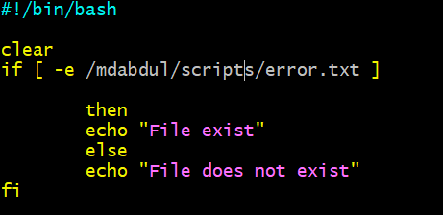

Give permissions to script file

Execute the script file

./iferrortext.bash



**3. Check if a variable value is met**

#!/bin/bash

a=`date | awk '{print $1}'`

if [ "$a" == Mon ]

then

echo Today is $a

else

echo Today is not Monday

fi

create script file

vi ifvariablevaluemet.bash

write a script as above

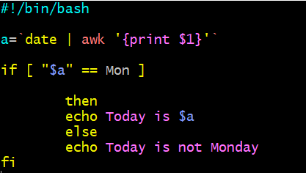

Give permission

Execute a script file

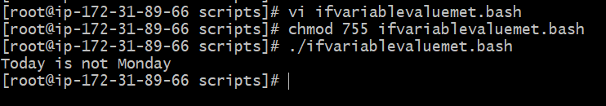

4. **Check the response and then output**

#!/bin/bash

clear

echo

echo "What is your name?"

echo

read a

echo

echo Hello $a sir

echo

echo "Do you like working in IT? (y/n)"

read Like

echo

if [ "$Like" == y ]

then

echo You are cool

elif [ "$Like" == n ]

then

echo You should try IT, it’s a good field

echo

fi

Create a file

Vi responseandoutput.bash

Write a script as above

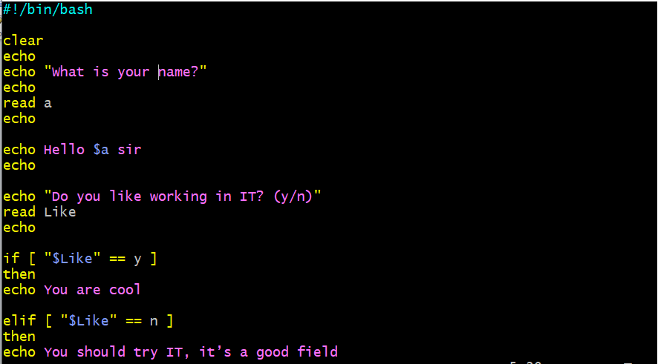



Execute the script file

./responseandoutput.bash

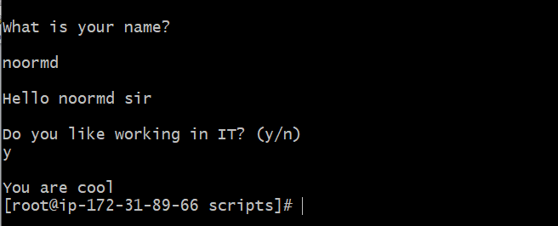

**5. Other If statements**

If the output is either Monday or Tuesday

if [ “$a” = Monday ] || [ “$a” = Tuesday ]

Test if the error.txt file exist and its size is greater than zero

if test -s error.txt

if [ $? -eq 0 ] If input is equal to zero (0)

if [ -e /export/home/filename ] If file is there

if [ "$a" != "" ] If variable does not match

if [ error_code != "0" ] If file not equal to zero (0)

create a script file

vi ifotherstatements.bash

not created file analyse the above scenario